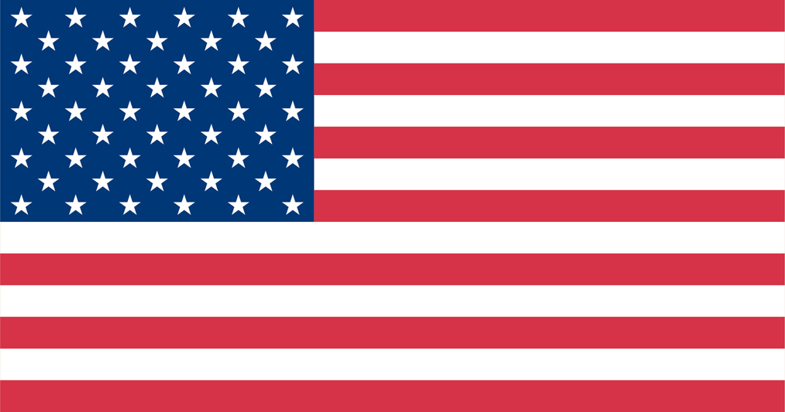
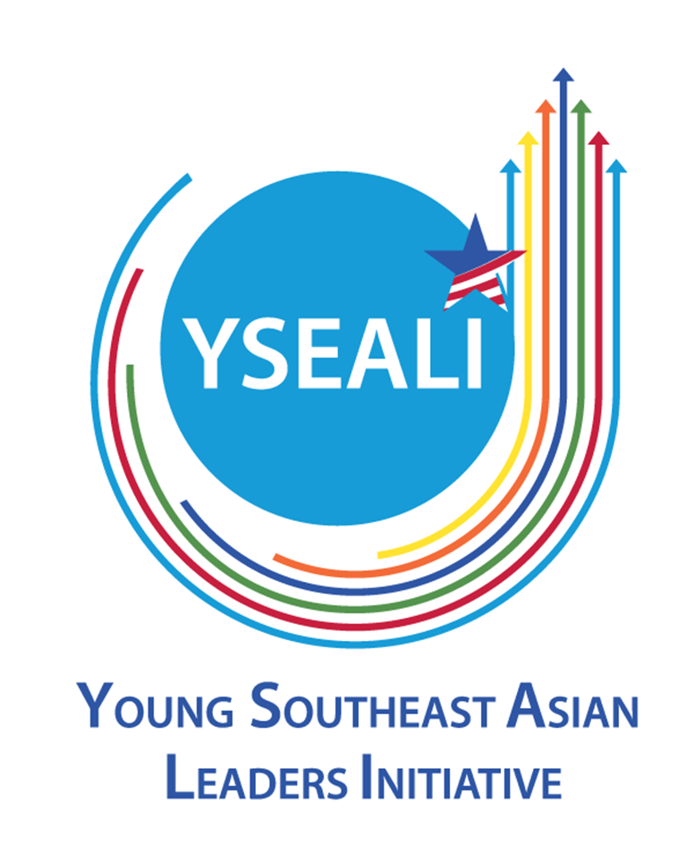

U.S. MISSION TO VIETNAM
PUBLIC AFFAIRS SECTIONS

ANNOUNCEMENT OF THE SPRING 2017 YOUNG SOUTHEAST ASIAN LEADERS INITIATIVE (YSEALI) ACADEMIC FELLOWSHIP

The U.S. Mission to Vietnam seeks candidates for the Spring 2017 Young Southeast Asian Leaders Initiative (YSEALI) Academic Fellowship on Civic Engagement, Environmental Issues, and Social Entrepreneurship and Economic Development. Vietnamese citizens between the ages 18 and 25, full-time undergraduate students or those who have graduated from college, university, or other institutions of higher learning, who demonstrate strong leadership qualities and potential in their university or place of work, an interest in community service and volunteerism, and have a good command of English, are invited to apply for the program. The application deadline is 5:00 PM, Monday, October 17th, 2016.
Program Overview
YSEALI is President Obama’s initiative to strengthen leadership development and networking in ASEAN, deepen engagement with young leaders on key regional and global challenges, and advance people-to-people ties between the United States and young and emerging Southeast Asian leaders.
Engaging and strengthening ties with young people is a critical element of the U.S. rebalance to the Asia-Pacific region. Recognizing that over 65 percent of ASEAN’s population is under the age of 35, YSEALI is an important investment in the next generation of Southeast Asian leaders. This initiative expands existing U.S. engagement in the region to better empower, support, and connect youth across Southeast Asia.
YSEALI Academic Fellowship invites Southeast Asian youth to universities in the United States, where they can deepen their knowledge about regional issues and share their experience and perspectives.

The YSEALI Academic Fellowship on Civic Engagement will provide Fellows with an overview of how citizens have shaped U.S. history, government, and society both as individuals and groups. The Institute will define civic engagement, examine its development in the U.S., and explore topics such as citizenship, community building, economic development, grassroots activism, political leadership, and volunteerism. Other topics such as civil rights, entrepreneurship, ethics, leadership, and media will be discussed. Fellows will also have the opportunity to leave the classroom to meet with community leaders, entrepreneurs, and representatives of non-profit organizations. The academic residency will be complemented by an educational tour that will take participants to another area of the U.S. where they will meet with local, state, private, and not-for-profit organizations working in the field. The Institute will then conclude with a visit to Washington, D.C. The hosts will be Arizona State University (from March 18, 2017- April 22, 2017), Kennesaw State University (from February 1, 2017- March 12, 2017), and the University of Nebraska-Omaha (from March 11, 2017- April 15, 2017).

The YSEALI Academic Fellowship on Environmental Issues will explore the role that environmental policy has played in the economic and political development of the United States. The Institute will use experiential learning techniques to expose participants to current themes in the field, including natural resource management, sustainable development/sustainable agricultural practices, food security, ecotourism, energy generation (new and traditional forms), and water management and treatment. The issues will be explored from numerous angles: local grassroots activism and civic initiatives, market-oriented approaches, and federal government policies and regulation. Finally, the Institute will explore environmental issues in the context of a globalized society, and draw comparisons between the United States and the participants’ home countries. Fellows will also have the opportunity to leave the classroom to meet with community leaders, and representatives of non-profit organizations. The academic residency will be complemented by an educational tour that will take participants to another area of the U.S. where they will meet with local, state, private, and nonprofit organizations working in the field. The Institute will then conclude with a 3 day program in Washington, D.C. The host will be the East-West Center (from February 21, 2017- March 26, 2017).

The YSEALI Academic Fellowship on Social Entrepreneurship and Economic Development will provide Fellows with an overview of entrepreneurial approaches that are employed to address social issues. The Institute will review the development, history, challenges, and successes of social enterprises and community leaders, in the United States and globally. Topics may include, but are not limited to, trade; investment; financial literacy; banking; microfinance; organizational development and management; grant writing; innovation; emerging markets and risk analysis; strategic business planning; corporate social responsibility; and, women and minorities in entrepreneurship. Students will also have the opportunity to leave the classroom to meet with community leaders, entrepreneurs, and representatives of nonprofit organizations. The academic residency will be complemented by an educational study tour that will take participants to New England and the Mid-Atlantic where they will meet with local, state, private, and nonprofit organizations working in the field. The Institute will then conclude with a 3 day program in Washington, DC. The hosts will be Arizona State University (from March 18, 2017- April 22, 2017) and the University of Connecticut (from March 18, 2017- April 21, 2017).
All participant costs, including program administration, international and domestic travel and ground transportation, book, cultural, mailing and incidental allowances, housing and subsistence expenses will be paid for by the U.S. Department of State.
Candidate Qualifications
Candidates nominated for this program should:
- be a YSEALI member. Join YSEALI at https://asean.usmission.gov/yseali/
- be between the ages of 18 and 25 at the time of application;
- be a Vietnamese citizen;
- be a resident of one of the following countries: Brunei, Burma, Cambodia, Indonesia, Laos, Malaysia, Philippines, Singapore, Thailand, or Vietnam;
- be a full-time undergraduate student or have graduated in the past four years from college, university, or other institutions of higher learning;
- be proficient in reading, writing, and speaking English;
- demonstrate strong leadership qualities and potential in their university, place of work, and/or community;
- demonstrate interest, knowledge, or professional experience in Civic Engagement, Environmental Issues, or Social Entrepreneurship and Economic Development;
- demonstrate a commitment or interest in community service, volunteerism, or mentorship;
- indicate a serious interest in learning about the United States and ASEAN as a region;
- be willing to actively participate in an intensive academic program, community service, and study tour;
- have a commitment to return to their home country to apply leadership skills and training to benefit their community, country, or the ASEAN region; and
- preferably have little or no prior study or travel experience in the United States.
Program timeline
- Submission deadline: Monday, October 17th, 2016
- Application screening and shortlisted candidates interviewed by selection committee: October 2016
- Final selection results available: February 2017
How to apply
Complete application dossier includes:
- Complete application form;
- Official transcripts for years of university study, and university degree if you already graduated
- A confidential letter of recommendation from teacher/professor (for undergraduate students); or from current supervisor (for working people)
These three documents should be combined in one PDF file, and submitted online.
Eligible candidates from Quang Tri province and to the north are requested to submit their complete application dossier online at http://goo.gl/CTp46P, and send any questions to:
Public Affairs Section
United States Embassy
YSEALI Academic Fellows Program
7 Lang Ha,
Ba Dinh, Hanoi
Tel: 84-4-3850 5000, ext. 6034
Email: pas.culture@gmail.com
Eligible candidates from Thua Thien-Hue province and to the south are requested to submit their complete application dossier online at http://goo.gl/6OzvR0, and send any questions to:
Public Affairs Section
United States Consulate General
YSEALI Academic Fellows Program
4 Le Duan, District 1
Ho Chi Minh City
Tel: 84-8-3520-4657
Email: PASHCMC@state.gov

FAQs about the program can be found at: https://vn.usembassy.gov/education-culture/yseali/yseali-fellows-faqs/

The application deadline is 5:00PM, Monday, October 17th, 2016. No exceptions will be made regarding the deadline.

